Power Management Unit

Version 1.0

SHMT Co., Ltd.

REVISION HISTORY
Version | Detail(굴림/Verdana 10pt bold) | Name | Date
1.0 | Power Management Unit Spec. Created | East | 2006-12-18

Technical documents
Copyright © 2006 Shmt Limited. All rights reserved.

Confidentiality Status
This document is NOT OPEN ACCESS. The distribution is restricted to certified company.
This document is CONFIDENTIAL.

Feedback on this document
If you have any comments on this document, please contact your channel to our company.

Shmt Web address
http://www.shmt.com

Contents

1. Function Description 7
1.1. Overview 7
1.1.1. Feature 7
1.1.2. Block Diagram 8
1.2. Operation 8
1.2.1. Clock Control Block 8
1.2.2. Power Manage State Machine 9
1.2.3. Reset Control Block 11
1.3. Register Description 12
1.3.1. Power Management Unit Registers 12
1.3.2. Power Management Control Register 13
1.3.3. Clock Divide Register 14
1.3.4. PLL Lock Wait Register 15
1.3.5. PLL Set Register 15

Figures

Figure 3 Power On Configuration & PLL Lock Time Diagram 11

Tables
Table 1-1 Power Management Unit Registers(Base Address : 1FFF 0000h) 12
Table 1-2 Power Management Control Register Description(Offset : 0000 0000h) 13
Table 1-3 Clock Divide Register Description(Offset : 0000 0004h) 14

Function Description

Overview

Clock Control Block과 Power Manage State Machine, Reset Control Block으로 나눌 수 있다.

Feature

- Support Slow Mode.
- Operate by External Clock divided or not
- Support CPU Idle Mode.
- Disconnect Only CPU Clock
- Wake Up From Any Interrupt
- Support Power Down Mode.
  - Disconnect All Clock
  - Wake Up From External Interrupt

Block Diagram

Figure 1 Clock Distribution Block Diagram
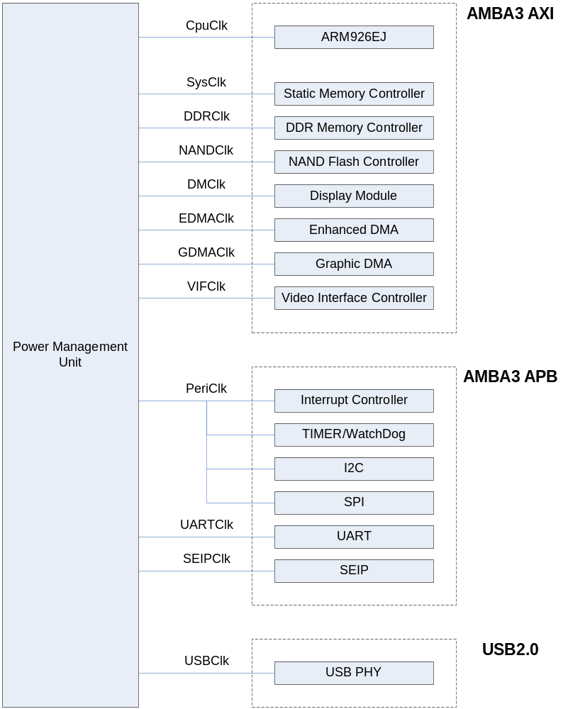

Operation

Clock Control Block

외부 27MHz Oscillator의 입력을 받은 MPLL에서 200MHz Clock을 만들어서 CpuClk, SysClk, PeriClk, LcdClk을 만들고, 외부 Crystal 입력을 분주하여 USB로 Clock을 건네 주는 역할을 한다.
정상 동작 모드의 예를 들면 200MHz Clock은 CPU(2x mode) 나 DDR SDRAM Data Control을 위해 사용되고, 버스나 DMA는 100MHz로 동작하고 SEIP를 제외한 Peripheral은 50MHz로 동작한다

Figure 2 Clock Control Block Diagram
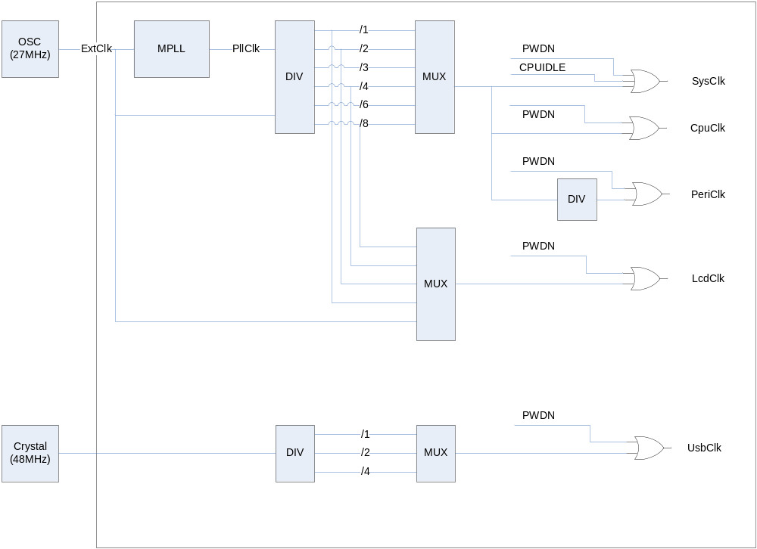

Power Manage State Machine

POC State
Power On Configuration
외부 Reset(ExtResetb)이 풀리면 이 State로 들어오게 되고, Pad 입력 쪽의 Pull-up이나 Pull-Down Resistor에 의해 Chip 초기 설정 Configuration이 가능하다.
16 Cycle 이상의 POC나 SlowEn Register가 Set 되면 SLOW State로 넘어 간다.

SLOW State
외부 Clock(ExtClk)에 의해 System이 동작 하는 상태이고, PLL이 Set 되거나(PllSetEnd) SlowEn Register가 Clear(SlowDis)되면 LOCK State로 넘어간다.

LOCK State
PLL이 Locking 될 때까지 기다리는 시간이다. 이 시간은 Register로 변경 가능하다.
PLL이 Locking 되면 NORMAL State로 넘어간다.

NORMAL State
System내의 모든 Clock이 동작하는 상태이다.
각 블록의 Clock Enable에 의해 각각의 Power Down이 가능하다.

CPUIDLE State
CPU Clock이 Disable 되는 상태이다.

PWDN State
각 블록의 Clock Enable과 상관 없이 System내의 모든 Clock이 Disable 되는 상태이다.

Figure 3 Power Manage State Machine Block Diagram
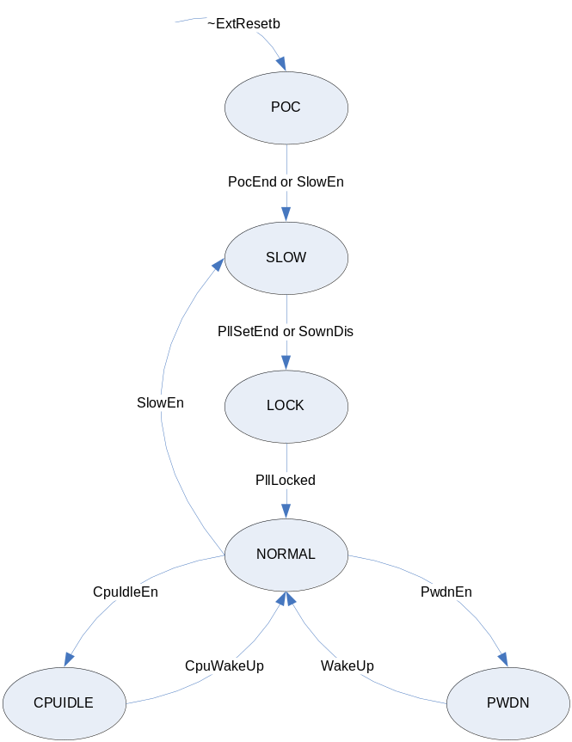

Reset Control Block

다음 그림과 같이 외부 클럭의 16 사이클 동안 Power On Configuration이 이루어 지고 약 500us의 PLL Lock Time이 지나면 Internal은 정상적인 PLL 클럭으로 동작 하게 된다.

Figure 1 Power On Configuration & PLL Lock Time Diagram
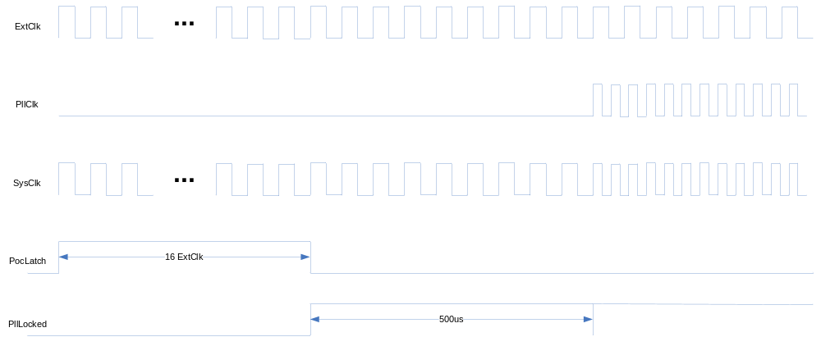

Register Description

Power Management Unit Registers

Table 1-1 Power Management Unit Registers(Base Address : 1FFF 0000h)
Offset | Name | R/W | Description | Init. value
0000h | PMCON | RW | Power Manage Control Register | 0000 3004h
0004h | CLKDIV | RW | Clock Divide Register | 0000 0000h
0008h | LOCWAIT | RW | PLL Lock Wait Register | 0000 FFFFh
000Ch | PLLSET | RW | PLL Set Register | 0000 0410h

Power Management Control Register

Figure 2-1 Power Management Control Register Bits
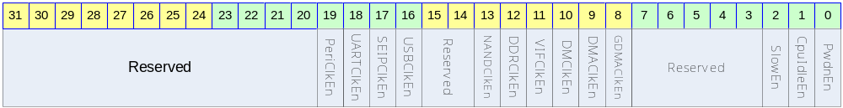

Table 1-2 Power Management Control Register Description(Offset : 0000 0000h)
Bits | Name | R/W | Description | Init. value
[31:20] |  |  | Reserved | 0
[19] | PeriClkEn | RW | VIF/TIMER/WDT/I2C/SPI Clock Enable  1 : Enable  0 : Disable | 0
[18] | UARTClkEn | RW | UART Clock Enable  1 : Enable  0 : Disable | 0
[17] | SEIPClkEn | RW | SEIP Clock Enable  1 : Enable  0 : Disable | 0
[16] | USBClkEn |  | USB Clock Enable  1 : Enable  0 : Disable | 0
[15:14] |  | RW | Reserved
[13] | NANDClkEn | RW | NAND Flash Controller Clock Enable  1 : Enable  0 : Disable | 1
[12] | DDRClkEn | RW | DDR Memory Controller Clock Enable  1 : Enable  0 : Disable | 1
[11] | VIFClkEn | RW | External Video Interface Module Clock Enable  1 : Enable  0 : Disable | 0
[10] | DMClkEn | RW | Display Module Clock Enable  1 : Enable  0 : Disable | 0
[9] | DMAClkEn | RW | DMA Module Clock Enable  1 : Enable  0 : Disable | 0
[8] | GDMAClkEn | RW | Graphic DMA Module Clock Enable  1 : Enable  0 : Disable | 0
[7:3] |  |  | Reserved
[2] | SlowEn | RW | Slow Mode Enable  1 : Enable  0 : Disable | 1
[1] | CpuIdleEn | RW | CPU Idle Mode Enable  1 : Enable  0 : Disable | 0
[0] | PwdnEn | RW | Power Down Enable  1 : Enable  0 : Disable | 0

Clock Divide Register

Figure 2-2 Clock Divide Register Bits
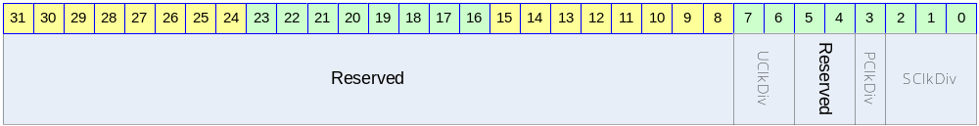

Table 1-3 Clock Divide Register Description(Offset : 0000 0004h)
Bits | Name | R/W | Description | Init. value
[31:8] |  |  | Reserved | 0
[7:6] | UClkDiv | RW | USB Clock Divide  0 : Bypass UsbClk  1 : Divide By 2 UsbClk  2 : Divide By 4 UsbClk | 0
[5:4] |  |  | Reserved | 0
[3] | PClkDiv | RW | Peri. Clock Divide  0 : Bypass SysClk  1 : Divide By 2 SysClk | 1
[2:0] | SClkDiv | RW | System Clock Divide  0 : Bypass MPllClk  1 : Divide By 2 MPllClk  2 : Divide By 3 MPllClk  3 : Divide By 4 MPllClk  4 : Divide By 6 MPllClk  5 : Divide By 8 MPllClk | 0

PLL Lock Wait Register

Figure 2-3 PLL Lock Wait Register Bits
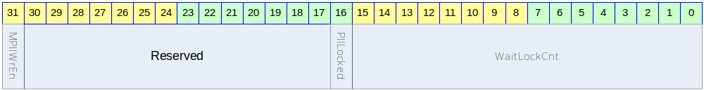

Table 1-4 PLL Lock Wait Register Description(Offset : 0000 0008h)
Bits | Name | R/W | Description | Init. value
[31] | MPllWrEn | RW | PLL Value Write Enable  이 값을 1 로 써야지만 PLL 값을 설정할 수 있다. | 0
[30:17] |  | RW | Reserved | 0
[16] | PllLocked | R | PLL is Locked  0 : UnLocked  1 : Locked | 0
[15:0] | WaitLockCnt | RW | PLL Lock Wait Value | ffffh

PLL Set Register

Figure 2-4 PLL Set Register Bits
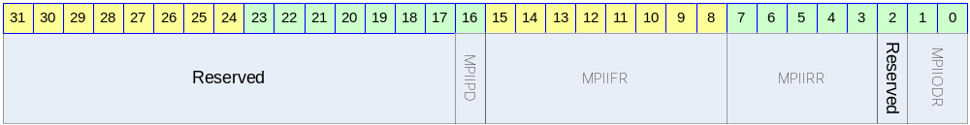

Table 1-5 PLL Set Register Description(Offset : 0000 000Ch)
Bits | Name | R/W | Description | Init. value
[30:17] |  | RW | Reserved | 0
[16] | MPllPD | RW | PLL Power Down Enable  0 : Enable  1 : Disable | 0
[15:8] | MPllFR | RW | FeedBack Divisor | 25d
[7:3] | MPllRR | RW | Input Divisor | 5h
[2] |  |  | Reserved | 0
[1:0] | MPllODR | RW | Output Divisor  ‘2’ 이상의 값을 가져야 PLL 출력 클럭의 duty가 50/50 에 근접하게 된다. | 2

FREF = FIN / NR
FVCO = FOUT * NO
FOUT = FIN * NF / (NR*NO), where FREF is the comparison frequency for the PFD.
For proper operation in normal mode, the following constraints must be satisfied:
2 MHz ≤ FREF ≤ 8 MHz
200 MHz ≤ FVCO ≤ 400 MHz
50 MHz ≤ FOUT ≤ 400 MHz

Example I: To synthesize a 200 MHz output clock with an input frequency FIN = 15 MHz.
1. Set MPllWrEn = 1.
2. Set NR to obtain FREF within the PFD comparison frequency range:
Let FREF = 5 MHz, Since FREF = FIN / NR,
NR = FIN / FREF = 15 MHz / 5 MHz = 3
3. MPllRR = NR = 3 = 000112
4. Set NO and ensure FVCO within the VCO operating range:
Set NO = 1
FVCO = FOUT * NO
FVCO = 200 MHz * 1 􀃆 within the VCO operating range
5. MPllODR = 012
6. Set NF to obtain the FOUT frequency:
NF = FOUT * NR * NO / FIN
NF = 200 MHz * 3 * 1 / 15 MHz = 40
6. MPllFR = NF/2 = 20 = 000101002

*** 자세한 사항은 TSMC PLL databook를 참조.

